SCHOOL

Trial WACE Examination, 2012

Question/Answer Booklet

MATHEMATICS 2A/2B
SOLUTIONS

Section One:

Calculator-free

Student Number: In figures

In words

Your name

Time allowed for this section
Reading time before commencing work: five minutes
Working time for this section: fifty minutes

Materials required/recommended for this section

To be provided by the supervisor
This Question/Answer Booklet
Formula Sheet

To be provided by the candidate
Standard items: pens, pencils, pencil sharpener, eraser, correction fluid/tape, ruler, highlighters

Special items: nil

Important note to candidates

No other items may be used in this section of the examination. It is your responsibility to ensure that you do not have any unauthorised notes or other items of a non-personal nature in the examination room. If you have any unauthorised material with you, hand it to the supervisor before reading any further.

Structure of this paper

Section | Number of questions available | Number of questions to be answered | Working time (minutes) | Marks available | Percentage of exam
Section One:  Calculator-free | 7 | 7 | 50 | 50 | 33
Section Two:  Calculator-assumed | 13 | 13 | 100 | 100 | 67
 |  |  | Total | 150 | 100

Instructions to candidates

- The rules for the conduct of Western Australian external examinations are detailed in the Year 12 Information Handbook 2012. Sitting this examination implies that you agree to abide by these rules.

- Write your answers in the spaces provided in this Question/Answer Booklet. Spare pages are included at the end of this booklet. They can be used for planning your responses and/or as additional space if required to continue an answer.
- Planning: If you use the spare pages for planning, indicate this clearly at the top of the page.
- Continuing an answer: If you need to use the space to continue an answer, indicate in the original answer space where the answer is continued, i.e. give the page number. Fill in the number of the question(s) that you are continuing to answer at the top of the page.

- Show all your working clearly. Your working should be in sufficient detail to allow your answers to be checked readily and for marks to be awarded for reasoning. Incorrect answers given without supporting reasoning cannot be allocated any marks. For any question or part question worth more than two marks, valid working or justification is required to receive full marks. If you repeat an answer to any question, ensure that you cancel the answer you do not wish to have marked.

- It is recommended that you do not use pencil, except in diagrams.

Section One: Calculator-free (50 Marks)
This section has seven (7) questions. Answer all questions. Write your answers in the spaces provided.

Working time for this section is 50 minutes.

Question 1 (7 marks)
(a) Write in simplest form 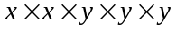. (1 mark)

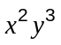

(b) Evaluate 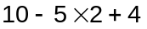. (1 mark)
4

(c) Expand and then simplify 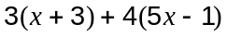. (2 marks)

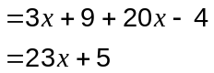

(d) Simplify and then factorise 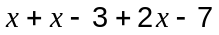. (2 marks)
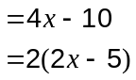

(e) The population of Canberra is estimated to be 365 thousand. Write this number in scientific notation. (1 mark)
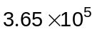

Question 2 (6 marks)
The daily rainfall figures (in mm) recorded during September at a coastal location were as follows:

0 | 3.2 | 9.4 | 1.0 | 2.6 | 0.2 | 0.6 | 0 | 0 | 0 | 0 | 0 | 5.2 | 3.6 | 0.6
3.0 | 11.4 | 11.0 | 14.4 | 0.6 | 3.2 | 2.4 | 0 | 0 | 0 | 3.2 | 9.8 | 4.4 | 0 | 0.2

(a) What is the range of this data? (1 mark)
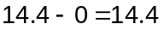

(b) Group this data into the classes shown in the table below. (2 marks)

Rainfall (mm) | Frequency
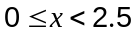 | 17
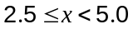 | 7
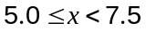 | 1
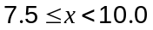 | 2
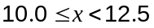 | 2
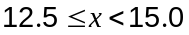 | 1

(c) On the axes below, draw a histogram to represent this rainfall data. (2 marks)
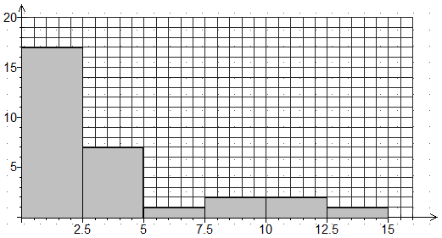
(d) Give one disadvantage of presenting the rainfall data in a table rather than as a histogram.
(1 mark)
Not easy to see the distribution of the data.

Question 3 (6 marks)
(a) The probability of picking a red king from a shuffled pack of cards is 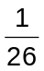. What is the probability of not picking a red king from a shuffled pack of cards? (1 mark)
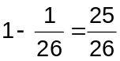

(b) A bag contains three red, two white and five green marbles. If each of the marbles has an equal chance of being chosen, what is the probability that a marble picked at random is green or white? (1 mark)
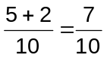

(c) A student was simulating playing a game in which the result was either a win, lose or draw. The student calculated that the chance of winning was 65%, the chance of losing was one-fifth, and the chance of a draw was 0.25.

Explain why the student must have made a mistake in their calculations. (2 marks)
Probabilities should add up to 1, but in fact add up to 1.1

(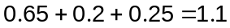)

(d) A canteen manager noticed that over the last year, the probability that a customer included a portion of chips with their order was one-quarter. One day, the canteen received 220 orders.

(i) How many portions of chips would the manager expect to be ordered on this day?
(1 mark)
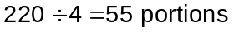

(ii) The canteen actually sold 81 portions of chips on this day. Should the manager be surprised? (1 mark)
No, as predictions are not always realised and 81 portions is not unrealistic in this situation.

Question 4 (8 marks)
(a) The perimeter of a rectangle is given by the formula 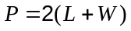.

(i) Find when 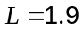cm and 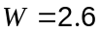cm. (1 mark)

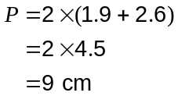

(ii) Find 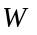when 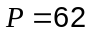cm and 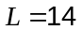cm. (2 marks)
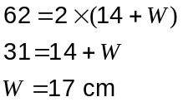

(b) In a class of 28 students there are 4 more boys than girls. How many boys are there in the class? (1 mark)
16 boys

(c) Solve for the equations

(i) 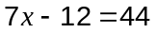 (1 mark)
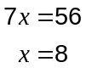

(ii) 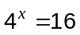 (1 mark)
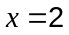

(iii) 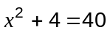 (2 marks)
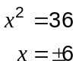
Question 5 (8 marks)
Three spinners are shown below made from a regular pentagon, a square and a regular octagon.
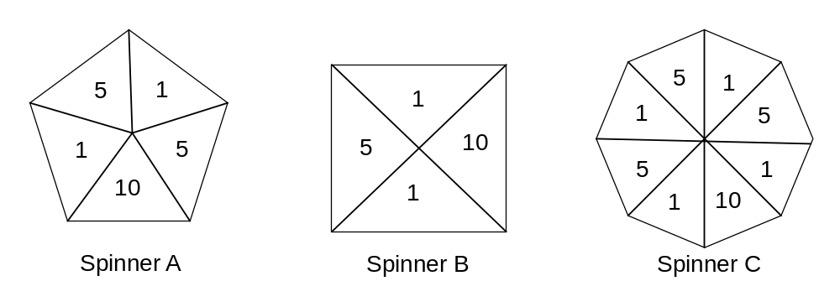

(a) Which spinner is least likely to spin a score of 10? (1 mark)
Spinner C

(b) Which spinner is most likely to spin a score of 5? Show how you decided. (2 marks)
Spinner A with probability 2/5.
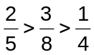

(c) How many scores of 1 would you expect when spinner A is spun 50 times? (1 mark)
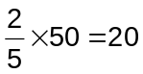

(d) One of the spinners is spun 160 times with the results shown in the frequency table.
Number | Frequency
1 | 87
5 | 52
10 | 21

Which spinner do you think was used and why?

(2 marks)
Spinner C, as would expect about 20 tens with this spinner (expect about 30 with A and 40 with B).

(e) A student wishes to simulate the random selection of one coloured ball at a time from a bag using one of the spinners. If the bag contains 8 balls, half of which are red, two are green and the rest blue, which spinner should they use? Briefly explain how the simulation would work. (2 marks)
Spinner B.
A spin of 1 would be a red ball, a spin of 5 a green and a spin of 10 a blue.

Question 6 (8 marks)
The graph below shows the number of marriages per year in Australia from 2000 to 2010.
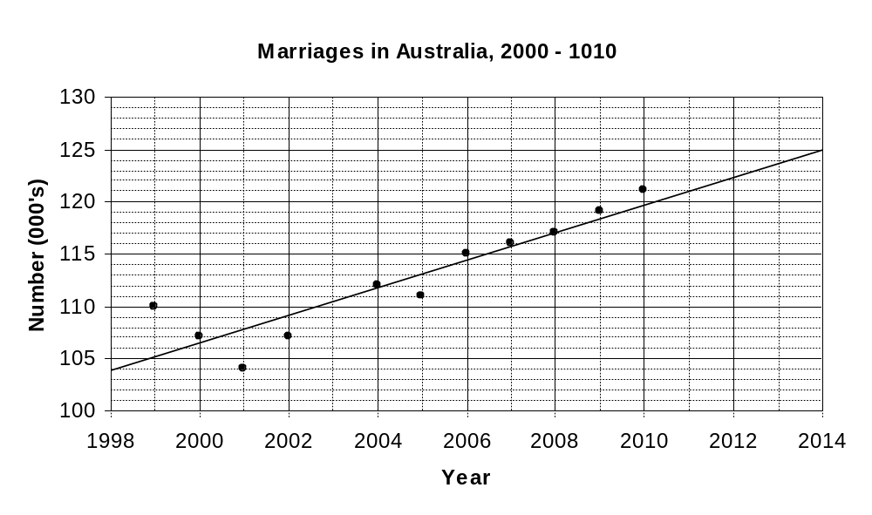
(a) Describe the trend in the number of marriages per year in Australia over this period.
(1 mark)
Over this period they have been increasing.

(b) There were approximately 110 000 marriages in 1999. Add this point to the graph above.
(1 mark)

(c) Draw a trend line on the graph. (2 marks)

(d) Use your trend line to estimate the number of marriages in:

(i) 2003 (1 mark)
110 500 marriages

(ii) 2013 (1 mark)
123 500 marriages

(e) One of your estimates in (d) may need to be treated with caution. State which estimate this is and briefly explain why. (2 marks)
The estimate for 2013 involves extrapolation and so must be treated with caution.

Question 7 (7 marks)
Point A has been plotted on the axes below.
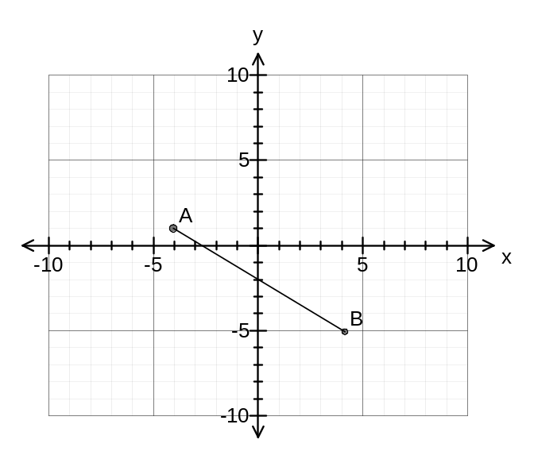
(a)
(i) What are the coordinates of point A? (1 mark)
(-4, 1)

(ii) Plot the point B(4, -5) on the axes above. (1 mark)

(b)
(i) Calculate the distance between the points A and B if one unit on each axis is one centimetre. (2 marks)
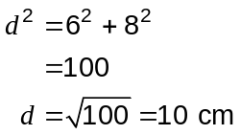

(ii) Determine the gradient of the straight line passing through the points A and B.
(1 mark)
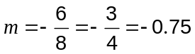

(c) Determine the equation of the straight line with a gradient of 4 passing through the point C(3, 2). (2 marks)
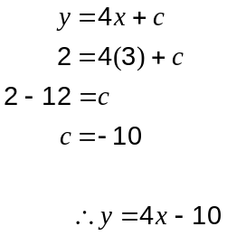

Additional working space

Question number: _________

Additional working space

Question number: _________

This examination paper may be freely copied, or communicated on an intranet, for non-commercial purposes within educational institutes that have purchased the paper from WA Examination Papers provided that WA Examination Papers is acknowledged as the copyright owner. Teachers within purchasing schools may change the paper provided that WA Examination Paper's moral rights are not infringed.

Copying or communication for any other purposes can only be done within the terms of the Copyright Act or with prior written permission of WA Examination papers.

Published by WA Examination Papers
PO Box 445 Claremont WA 6910

